Uveal Melanoma
Protocol applies to malignant melanoma of the uvea.

Based on AJCC/UICC TNM, 7th edition
Protocol web posting date: ____________
Protocol effective date: ____________

Procedures
• Resection (Local Resection, Enucleation, Limited or Complete Exenteration)

Authors
Hans E. Grossniklaus MD, MBA
Departments of Ophthalmology and Pathology, Emory University School of Medicine, Atlanta, Georgia
Tero Kivëla MD
Departments of Ophthalmology and Pathology, University of Helsinki, Findland
J. William Harbour MD
Department of Ophthalmology, Washington University School of Medicine, St. Louis Missouri
Paul Finger MD
Department of Ophthalmologyk, New York Eye and Ear Hospital, New York, New York
For the Members of the Cancer Committee, College of American Pathologists

Neurological and Eye Tumors Committee Members
_______________________________________________________
_______________________________________________________
_______________________________________________________

Previous contributors: David L. Page, Harry H. Brown, MD

Surgical Pathology Cancer Case Summary (Checklist)

Protocol web posting date: ____________
Protocol effective date: ____________

UVEAL MELANOMA: Resection

Patient name:
Surgical pathology number:

MACROSCOPIC (check 1 response unless otherwise indicated) (Note A)

Specimen Type
___Local resection
___ Enucleation
___ Limited exenteration
___ Complete exenteration
___ Other (specify): ____________________________
___ Not specified

Specimen Size

For Enucleation
Anteroposterior diameter: ___ mm
Horizontal diameter: ___ mm
Vertical diameter: ___ mm
Length of optic nerve: ___ mm
Diameter of optic nerve: ___ mm
___ Cannot be determined (see Comment)

For Exenteration
Greatest dimension: ___ mm
*Additional dimensions: ___ x ___ mm
___ Cannot be determined (see Comment)

Laterality
___ Right
___ Left
___ Unspecified

Tumor Site and Extent (macroscopic examination/transillumination)
(check all that apply) (Note B)
___ Cannot be determined
___ Superotemporal quadrant of globe
___ Superonasal quadrant of globe
___ Inferotemporal quadrant of globe
___ Inferonasal quadrant of globe
___ Anterior chamber
___ Extrascleral extension
___ Optic nerve

*Tumor Basal Dimensions on Transillumination
*___ Cannot be determined
*Specify: ___ x ___ mm

Tumor Dimensions After Sectioning (Note C)
___ Cannot be determined
___ Base at cut edge: ___ mm
*___ Height at cut edge: ___ mm
___ Maximal tumor height: ___ mm

*Tumor Location After Sectioning (Note D)
*___ Cannot be determined
*___ Distance from anterior edge of tumor to limbus at cut edge: ___ mm
*___ Distance of posterior margin of tumor base from edge of optic disc: ___ mm

Tumor Involvement or Gross Pathology of Other Ocular Structures
(check all that apply)
___ Cannot be determined
___ Sclera
___ Vortex vein(s)
___ Optic disc
___ Vitreous
___ Choroid
___ Ciliary body
___ Iris
___ Lens
___ Anterior chamber
___Extrascleral extension (anterior)
___ Extrascleral extension (posterior)
___ Angle/Schlemm’s canal
*___ Cornea
*___ Retinal detachment

Growth Pattern
___ Cannot be determined
___ Solid mass
___ Diffuse (ciliary body ring)
___ Diffuse (flat)

MICROSCOPIC (check 1 response unless otherwise indicated)

Histologic Type (Note E)
___ Cannot be determined
___ Spindle cell type
*___ Spindle cell type, spindle A
*___ Spindle cell type, spindle B
___ Epithelioid cell type
___ Mixed cell type
___ Necrotic
*___ Balloon cell

*Tumor Location
*___Anterior margin between equator and iris
*___Anterior margin between disc and equator
*___Posterior margin between equator and iris
*___Posterior margin between disc and equator
*___ Cannot be determined
*___ None of above

Scleral Involvement
___ Cannot be determined
___ None
___ Extrascleral
___ Intrascleral

Involvement of Other Structures (check all that apply)
___ Cannot be determined
___ Vortex vein
___ Optic Nerve
___ Vitreous
___ Retina
___ Angle/Schlemm’s canal
___ Other(s) (specify): _________________________

Margins
___ Cannot be assessed
___ No melanoma at margins
___ Extrascleral extension (for enucleation specimens)
___ Other margin involved (specify): _________________________

Pathologic Staging (pTNM) (Note F)

Primary Tumor (pT): Iris
___ pTX: Primary tumor cannot be assessed
___ pT0: No evidence of primary tumor
pT1: Tumor limited to the iris
___ pT1a: Tumor limited to the iris not more than 3 clock hours in size
___ pT1b: Tumor limited to the iris more than 3 clock hours in size
___ pT1c: Tumor limited to the iris with melanomalytic glaucoma
pT2: Tumor confluent with or extending into the ciliary body and/or choroid
___ pT2a: Tumor confluent with or extending into the ciliary body and/or choroid with secondary glaucoma
pT3: Tumor confluent with or extending into the ciliary body and/or choroid with extrascleral extension
___ pT3a: Tumor confluent with or extending into the ciliary body with extrascleral extension and secondary glaucoma
pT4: Tumor with extraocular extension
___pT4a: Tumor with extrascleral extension less than or equal to 5 mm in diameter
___pT4b: Tumor with extraslceral extension more than 5 mm in diameter

Primary Tumor (pT): Ciliary Body and Choroid
Ciliary Body and Choroid
Primary ciliary body and choroidal melanomas are classified according to the four tumor size categories below:

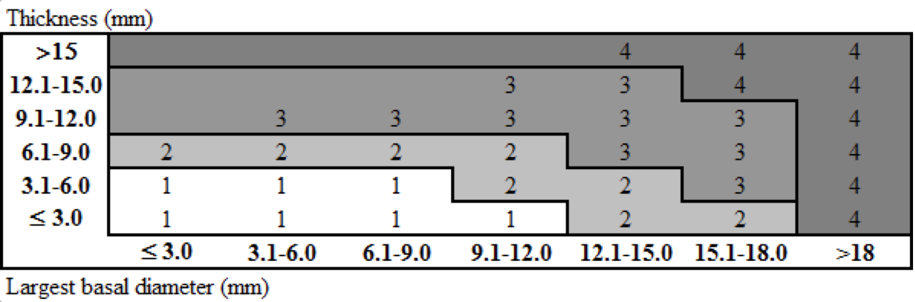
___pTX: Primary tumor cannot be assessed
___pT0: No evidence of primary tumor
pT1:Tumor size category 1
___pT1a:Tumor size category 1 without ciliary body involvement and extraocular extension
___pT1b:Tumor size category 1 with ciliary body involvement
___pT1c:Tumor size category 1 without ciliary body involvement but with extraocular extension less than or equal to 5 mm in diameter
___pT1d :Tumor size category 1 with ciliary body involvement and extraocular extension less than or equal to 5 mm in diameter

pT2:Tumor size category 2
___pT2a :Tumor size category 2 without ciliary body involvement and extraocular extension
___pT2b:Tumor size category 2 with ciliary body involvement
___pT2c:Tumor size category 2 without ciliary body involvement but with extraocular extension less than or equal to 5 mm in diameter
___pT2d:Tumor size category 2 with ciliary body involvement and extraocular extension less than or equal to 5 mm in diameter

pT3:Tumor size category 3
___pT3a:Tumor size category 3 without ciliary body involvement and extraocular extension
___T3b:Tumor size category 3 with ciliary body involvement
___pT3c:Tumor size category 3 without ciliary body involvement but with extraocular extension less than or equal to 5 mm in diameter
___pT3d:Tumor size category 3 with ciliary body involvement and extraocular extension less than or equal to 5 mm in diameter
pT4:Tumor size category 4
___pT4a:Tumor size category 4 without ciliary body involvement and extraocular extension
___pT4b:Tumor size category 4 with ciliary body involvement
___pT4c:Tumor size category 4 without ciliary body involvement but with extraocular extension less than or equal to 5 mm in diameter
___pT4d:Tumor size category 4 with ciliary body involvement and extraocular extension less than or equal to 5 mm in diameter
___pT4e:Any tumor size category with extraocular extension more than 5 mm in diameter

*Note 1: In clinical practice, the largest tumor basal diameter may be estimated in optic disc diameters (dd, average: 1 dd = 1.5 mm). Tumor thickness may be estimated in diopters (average: 2.5 diopters = 1 mm). However, techniques such as ultrasonography and fundus photography are used to provide more accurate measurements. Ciliary body involvement can be evaluated by the slit-lamp, ophthalmoscopy, gonioscopy and transillumination. However, high frequency ultrasonography (ultrasound biomicroscopy) is used for more accurate assessment. Extension through the sclera is evaluated visually before and during surgery, and with ultrasonography, computed tomography or magnetic resonance imaging.
†Note 2: When histopathologic measurements are recorded after fixation, tumor diameter and thickness may be underestimated because of tissue shrinkage.

HISTOPATHOLOGIC TYPE
The histopathologic types are:

Spindle cell melanoma (greater than 90% spindle cells)
Mixed cell melanoma (>10% epithelioid cells and <90% spindle cells)
Epithelioid cell melanoma (greater than 90% epithelioid cells)

HISTOLOGIC GRADE (pG)*
___pGX:Grade cannot be assessed
___pG1:Spindle cell melanoma
___pG2:Mixed cell melanoma
___pG3:Epithelioid cell melanoma

*Note 1: Because of general lack of agreement regarding which proportion of epithelioid cells classifies a tumor as mixed and epithelioid in type, some ophthalmic pathologists currently combine grades 2 and 3 (nonspindle, epithelioid cells detected) and contrast them with grade 1 (spindle, no epithelioid cells detected).

Regional Lymph Nodes (pN)
___pNX:Regional lymph nodes cannot be assessed
___pN0:No regional lymph node metastasis
___pN1: Regional lymph node metastasis

Distant Metastasis (pM)
___pMX:Distant metastasis cannot be assessed
___pM0:No distant metastasis
___pM1:Distant metastasis
___pM1a:Largest diameter of the largest metastasis ≤3 cm
___M1b:Largest diameter of the largest metastasis 3.1-8.0 cm
___M1c:Largest diameter of the largest metastasis ≥8 cm

*Additional Pathologic Findings (check all that apply) (Note G)
*___ None identified
*___ Mitotic rate (number of mitoses per 40X objective
with a field area of 0.152 mm² ): ____
*___ Necrosis
*___ Microvascular patterns
*___ Vascular invasion (tumor vessels or other vessels)
*___ Degree of pigmentation
*___ Inflammatory cells/tumor infiltrating lymphocytes
*___ Drusen
*___ Retinal detachment
*___ Invasion of Bruch’s membrane
*___ Nevus
*___ Hemorrhage
*___ Neovascularization
*___ Other (specify): ____________________________

*Comment(s)

Explanatory Notes

A. Fixative
The minimum recommended fixation time for whole globes with intraocular tumors is 48 hours. The globe should be fixed in an adequate volume of fixative with a 10:1 ratio of fixative volume to specimen volume recommended. Incisions or windows in the globe are not necessary for adequate penetration of fixative and are not recommended. Injection of fixative into the globe is also not recommended.

B. Orientation
The orientation of a globe may be determined by identification of extraocular muscle insertions, the optic nerve, and other landmarks, as illustrated in Figure 1. The terms temporal and nasal are generally used in place of lateral and medial with reference to ocular anatomy.

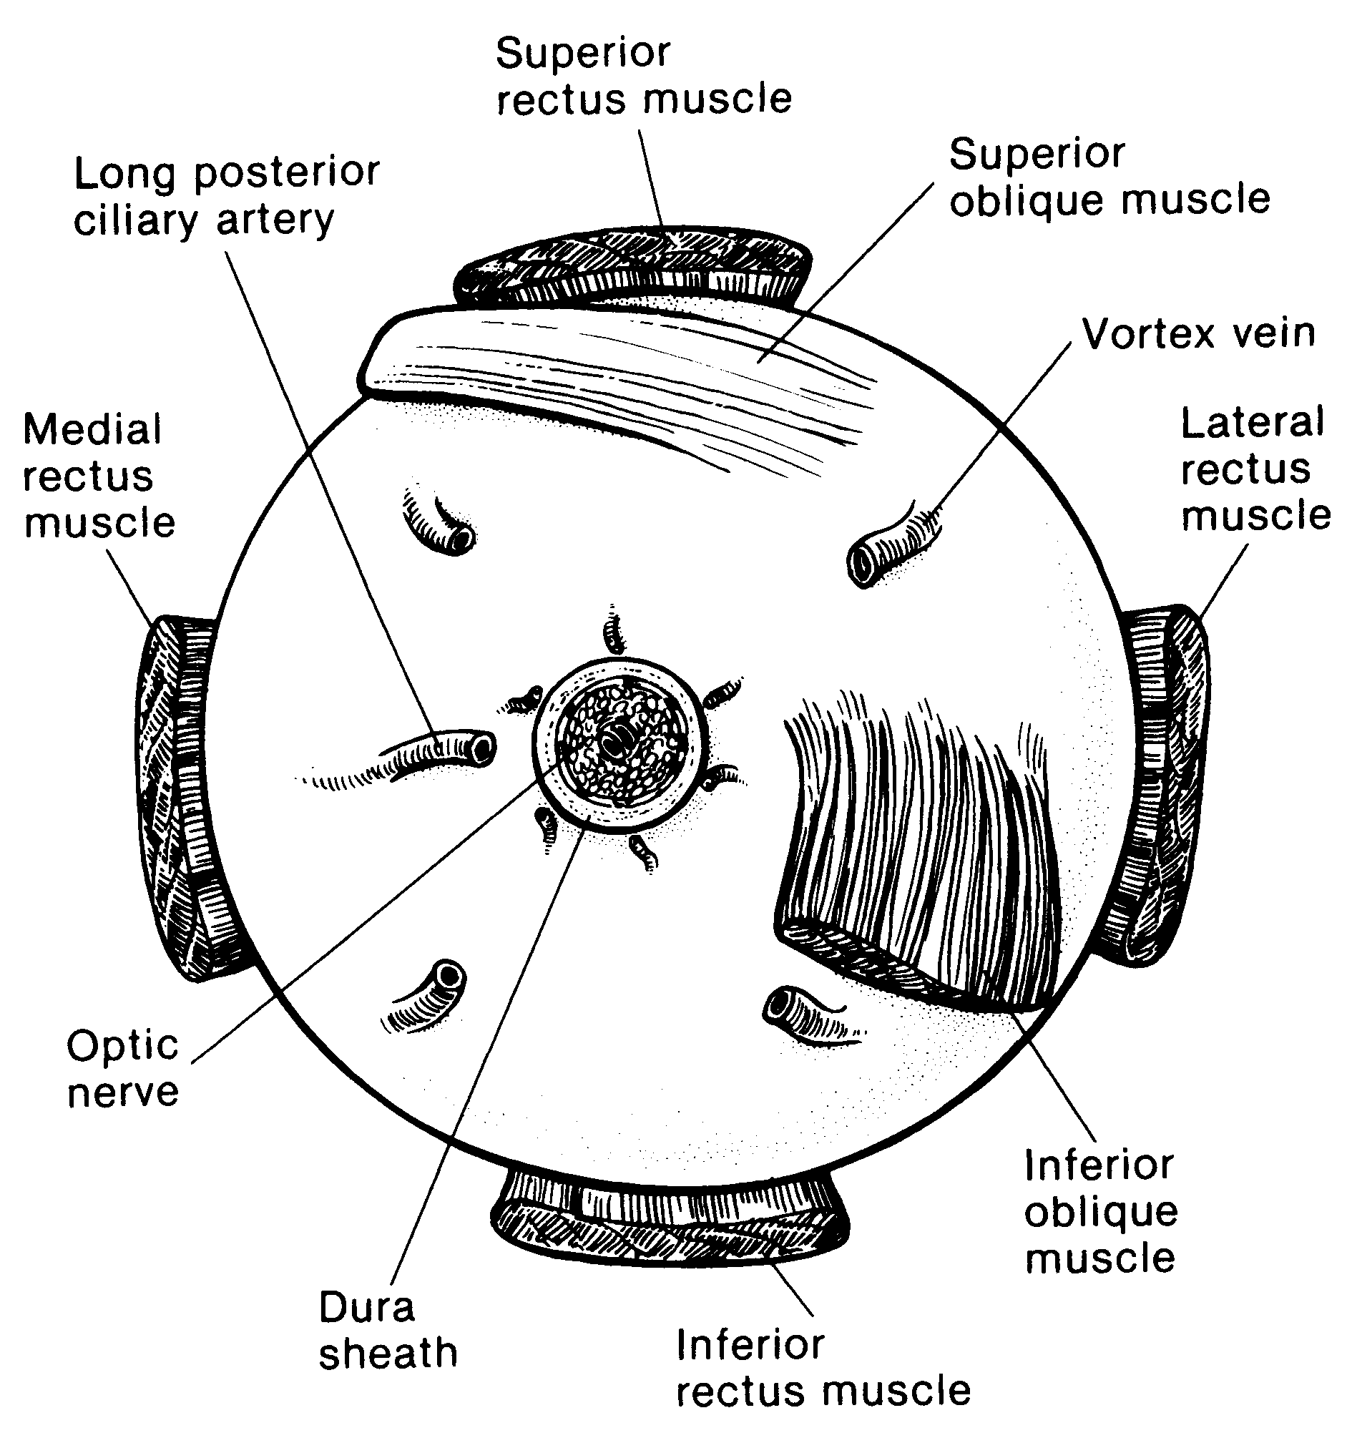
Figure 1. Anatomic landmarks of the posterior aspect of the globe (right eye). The position of the inferior oblique muscle relative to the optic nerve is most helpful in orienting the globe. The inferior oblique muscle insertion is located temporal (lateral) to the optic nerve on the sclera, and its fibers travel inferonasally from its insertion. The long posterior ciliary artery is often seen as a blue-gray line in the sclera on either side of the optic nerve and marks the horizontal meridian of the globe. Reprinted with permission from WB Saunders Company.

C. Tumor Size
Tumor size has prognostic significance. Many studies of choroidal and ciliary body melanoma have defined small tumors as being less than 10 mm in greatest diameter.⁴ More recently, an ongoing study started in 1986, the Collaborative Ocular Melanoma Study^{17,18} defined the following size classification based on clinical measurements.

Small tumors#: Smaller than medium or large tumors defined below
Medium tumors: Greater than or equal to 2.5 mm, less than or equal to 10 mm in height, and less than or equal to 16 mm in basal diameter
Large tumors: Greater than 10 mm in height or
Greater than 2 mm in height and greater than16 mm in basal diameter or
Greater than 8 mm in height with optic nerve involvement

# Small tumors have a more favorable prognosis.^{6,7}

D. Sectioning the Globe
The globe is generally sectioned in the horizontal or vertical plane with care to include the pupil and optic nerve in the section to be submitted for microscopic examination. If the mass cannot be included with horizontal or vertical sectioning, the globe is sectioned obliquely to include the tumor, pupil and optic nerve, as illustrated in Figure 2. Alternative methods of sectioning have been described.¹⁶
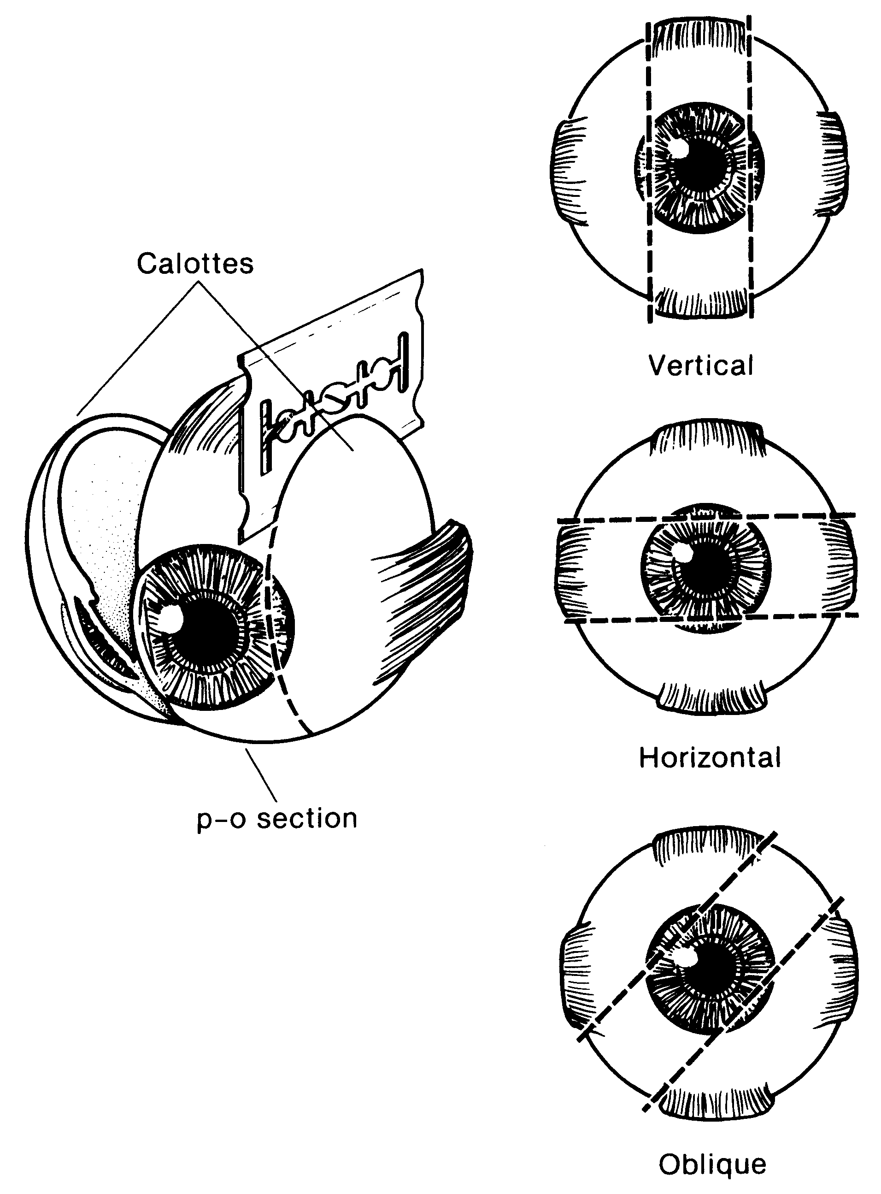
Figure 2. The most common methods of sectioning a globe. After transillumination, the tumor base is marked, if possible, and included in the pupil-optic (p-o) nerve section and submitted for processing. If tumor is found in either of the calottes, these may also be submitted for sectioning. The meridian in which the globe was sectioned should be included in the gross description of the pathology report. It is not uncommon to induce an artifactitious retinal detachment while sectioning the globe. This can be minimized by gentle handling and by avoiding a sawing motion with the blade. Reprinted with permission from WB Saunders Company.

E. Histologic Type
The modified Callender classification shown below is used for determining cell type, but has prognostic significance only for tumors of the choroid and ciliary body, not those of the iris, which generally have a benign course.¹⁻⁴ The American Joint Commission on Cancer (AJCC) defined the histopathologic types as follows^{19#}:

Spindle cell melanoma (greater than 90% spindle cells)
Mixed cell melanoma (>10% epithelioid cells and <90% spindle cells)
Epithelioid cell melanoma (greater than 90% epithelioid cells)

# Spindle cell melanomas have the most favorable prognosis, and epithelioid cell melanomas the least favorable in terms of survival.

F. TNM Stage Groupings
The American Joint Committee on Cancer (AJCC) and the International Union Against Cancer (UICC) TNM staging systems for uveal melanoma of the iris, ciliary body, and choroid are shown below.¹⁹

By AJCC/UICC convention, the designation “T” refers to a primary tumor that has not been previously treated. The symbol “p” refers to the pathologic classification of the TNM, as opposed to the clinical classification, and is based on gross and microscopic examination. pT entails a resection of the primary tumor or biopsy adequate to evaluate the highest pT category, pN entails removal of nodes adequate to validate lymph node metastasis, and pM implies microscopic examination of distant lesions. Clinical classification (cTNM) is usually carried out by the referring physician before treatment during initial evaluation of the patient or when pathologic classification is not possible.

Pathologic staging is usually performed after surgical resection of the primary tumor. Pathologic staging depends on pathologic documentation of the anatomic extent of disease, whether or not the primary tumor has been completely removed. If a biopsied tumor is not resected for any reason (eg, when technically unfeasible) and if the highest T and N categories or the M1 category of the tumor can be confirmed microscopically, the criteria for pathologic classification and staging have been satisfied without total removal of the primary cancer.
Primary Tumor
All Uveal Melanomas
TX Primary tumor cannot be assessed
T0 No evidence of primary tumor

Iris*
T1 Tumor limited to the iris
T1a Tumor limited to the iris not more than 3 clock hours in size
T1b Tumor limited to the iris more than 3 clock hours in size
T1c Tumor limited to the iris with melanonomalyticglaucoma
T2 Tumor confluent with or extending into the ciliary body, choroid or both
T2a Tumor confluent with or extending into the ciliary body, choroid or both, with melanomalytic glaucoma
T3 Tumor confluent with or extending into the ciliary body, choroid or both, with scleral extension
T3a Tumor confluent with or extending into the ciliary body, choroid or both, with scleral extension and melanomalytic glaucoma
T4 Tumor with extrascleral extension
T4a Tumor with extrascleral extension less than or equal to 5 mm in diameter
T4b Tumor with extrascleral extension more than 5 mm in diameter

* Note: Iris melanomas originate from, and are predominantly located in, this region of the uvea. If less than half of the tumor volume is located within the iris, the tumor may have originated in the ciliary body and consideration should be given to classifying it accordingly.

Ciliary Body and Choroid
Primary ciliary body and choroidal melanomas are classified according to the four tumor size categories as shown on page 5:

T1 Tumor size category 1
T1a Tumor size category 1 without ciliary body involvement and extraocular extension
T1b Tumor size category 1 with ciliary body involvement
T1c Tumor size category 1 without ciliary body involvement but with extraocular extension less than or equal to 5 mm in diameter
T1d Tumor size category 1 with ciliary body involvement and extraocular extension less than or equal to 5 mm in diameter

T2 Tumor size category 2
T2a Tumor size category 2 without ciliary body involvement and extraocular extension
T2b Tumor size category 2 with ciliary body involvement
T2c Tumor size category 2 without ciliary body involvement but with extraocular extension less than or equal to 5 mm in diameter
T2d Tumor size category 2 with ciliary body involvement and extraocular extension less than or equal to 5 mm in diameter

T3 Tumor size category 3
T3a Tumor size category 3 without ciliary body involvement and extraocular extension
T3b Tumor size category 3 with ciliary body involvement
T3c Tumor size category 3 without ciliary body involvement but with extraocular extension less than or equal to 5 mm in diameter
T3d Tumor size category 3 with ciliary body involvement and extraocular extension less than or equal to 5 mm in diameter
T4 Tumor size category 4
T4a Tumor size category 4 without ciliary body involvement and extraocular extension
T4b Tumor size category 4 with ciliary body involvement
T4c Tumor size category 4 without ciliary body involvement but with extraocular extension less than or equal to 5 mm in diameter
T4d Tumor size category 4 with ciliary body involvement and extraocular extension less than or equal to 5 mm in diameter
T4e Any tumor size category with extraocular extension more than 5 mm in diameter

*Note 1: In clinical practice, the largest tumor basal diameter may be estimated in optic disc diameters (dd, average: 1 dd = 1.5 mm). Tumor thickness may be estimated in diopters (average: 2.5 diopters = 1 mm). However, techniques such as ultrasonography and fundus photography are used to provide more accurate measurements. Ciliary body involvement can be evaluated by the slit-lamp, ophthalmoscopy, gonioscopy and transillumination. However, high frequency ultrasonography (ultrasound biomicroscopy) is used for more accurate assessment. Extension through the sclera is evaluated visually before and during surgery, and with ultrasonography, computed tomography or magnetic resonance imaging.
†Note 2: When histopathologic measurements are recorded after fixation, tumor diameter and thickness may be underestimated because of tissue shrinkage.

Regional Lymph Nodes (N)
NX Regional lymph nodes cannot be assessed
N0 No regional lymph node metastasis
N1 Regional lymph node metastasis

Distant Metastasis (M)
MX Distant metastasis cannot be assessed
M0 No distant metastasis
M1 Distant metastasis
M1a Largest diameter of the largest metastasis ≤3 cm
M1b Largest diameter of the largest metastasis 3.1-8.0 cm
M1c Largest diameter of the largest metastasis ≥8 cm

STAGE GROUPING

Stage I T1a N0 M0
Stage IIA T1b-d N0 M0
T2a N0 M0
Stage IIB T2b N0 M0
T3a N0 M0
Stage IIIA T2c-d N0 M0
T3b-c N0 M0
T4a N0 M0
Stage IIIB T3d N0 M0
T4b-c N0 M0
Stage IIIC T4d-e N0 M0
Stage IV Any T N1 M0
Any T Any N M1a-c

It should be noted that regional lymph node involvement is rare in uveal melanoma, but metastasis to the liver and direct extension into the orbit are more common.¹⁹

TNM Descriptors
For identification of special cases of TNM or pTNM classifications, the “m” suffix and “y,” “r,” and “a” prefixes are used. Although they do not affect the stage grouping, they indicate cases needing separate analysis.

The “m” suffix indicates the presence of multiple primary tumors in a single site and is recorded in parentheses: pT(m)NM.

The “y” prefix indicates those cases in which classification is performed during or following initial multimodality therapy (ie, neoadjuvant chemotherapy, radiation therapy, or both chemotherapy and radiation therapy). The cTNM or pTNM category is identified by a “y” prefix. The ycTNM or ypTNM categorizes the extent of tumor actually present at the time of that examination. The “y” categorization is not an estimate of tumor prior to multimodality therapy (ie, before initiation of neoadjuvant therapy).

The “r” prefix indicates a recurrent tumor when staged after a documented disease-free interval, and is identified by the “r” prefix: rTNM.

The “a” prefix designates the stage determined at autopsy: aTNM.

Additional Descriptors

Residual Tumor (R)
Tumor remaining in a patient after therapy with curative intent (eg, surgical resection for cure) is categorized by a system known as R classification, shown below.

RX Presence of residual tumor cannot be assessed
R0 No residual tumor
R1 Microscopic residual tumor
R2 Macroscopic residual tumor

For the surgeon, the R classification may be useful to indicate the known or assumed status of the completeness of a surgical excision. For the pathologist, the R classification is relevant to the status of the margins of a surgical resection specimen. That is, tumor involving the resection margin on pathologic examination may be assumed to correspond to residual tumor in the patient and may be classified as macroscopic or microscopic according to the findings at the specimen margin(s).

Vessel Invasion
By AJCC/UICC convention, vessel invasion (lymphatic or venous) does not affect the T category indicating local extent of tumor unless specifically included in the definition of a T category. In all other cases, lymphatic and venous invasion by tumor are coded separately as follows.

Lymphatic Vessel Invasion (L)
LX Lymphatic vessel invasion cannot be assessed
L0 No lymphatic vessel invasion
L1 Lymphatic vessel invasion

Venous Invasion (V)
VX Venous invasion cannot be assessed
V0 No venous invasion
V1 Microscopic venous invasion
V2 Macroscopic venous invasion

G. Other Pathologic Features of Prognostic Significance
Other histologic features with prognostic significance in choroidal and ciliary body melanoma include the number of mitoses in 40 high-powered fields, pigmentation, degree of inflammation, growth pattern (diffuse choroidal melanomas and ring melanomas of the ciliary body have a much less favorable prognosis), location of anterior margin of tumor, degree and patterns of vascularity, blood vessel invasion (both tumor vessels and normal vessels), tumor necrosis, extraocular extension and optic nerve involvement.⁴⁻¹⁵

References
1. Callender GR. Malignant melanotic tumors of the eye: a study of histologic types in 111 cases. Trans Am Acad Ophthalmol Otolaryngol. 1931;36:131-142.
2. McLean IW, Zimmerman LE, Evans RM. Reappraisal of Callenderís spindle A type of malignant melanoma of choroid and ciliary body. Am J Ophthalmol. 1978; 86:557-564.
3. McLean IW, Foster WD, Zimmerman LE. Modifications of Callenderís classification of uveal melanoma at the Armed Forces Institute of Pathology. Am J Ophthalmol. 1983;96:502-509.
4. Zimmerman LE. Malignant melanoma of the uveal tract. In: Spencer WH, ed. Ophthalmic Pathology. An Atlas and Textbook. 3rd ed. Philadelphia, Pa: WB Saunders Co; 1986:2072-2139.
5. Font RL, Spaulding AG, Zimmerman LE. Diffuse malignant melanoma of the uveal tract: a clinicopathologic report of 54 cases. Trans Am Acad Ophthalmol Otolaryngol. 1968;72:877-894.
6. McLean IW, Foster WD, Zimmerman LE. Prognostic factors in small malignant melanomas of choroid and ciliary body. Arch Ophthalmol. 1977;95:48-58.
7. Affeldt JC, Minckler DS, Azen SP, Yeh L. Prognosis in uveal melanoma with extraocular extension. Arch Ophthalmol. 1980;98:1975-1979.
8. McLean IW, Foster WD, Zimmerman LE. Uveal melanoma: location, size, cell type, and enucleation as risk factors in metastasis. Hum Pathol. 1982;13:123-132.
9. Weinhaus RS, Seddon JM, Albert DM, Gragoudas ES, Robinson N. Prognostic factor study of survival after enucleation for juxtapapillary melanomas. Arch Ophthalmol. 1985;103:1673-1677.
10. Gamel JW, McCurdy JB, McLean IW. A comparison of prognostic covariates for uveal melanoma. Invest Ophthalmol Vis Sci. 1992;33:1919-1922.
11. Folberg R, Peíer J, Gruman LM, et al. The morphologic characteristics of tumor blood vessels as a marker of tumor progression in primary human uveal melanoma: a matched case-control study. Hum Pathol. 1992;23:1298-1305.
12. Coleman K, Baak JP, Van Diest P, Mullaney J, Farrell M, Fenton M. Prognostic factors following enucleation of 111 uveal melanomas. Br J Ophthalmol. 1993;77:688-692.
13. Folberg R, Rummelt V, Parys-Van Ginderdeuren R, et al. The prognostic value of tumor blood vessel morphology in primary uveal melanoma. Ophthalmology. 1993;100:1389-1398.
14. Folberg R, Rummelt V, Gruman LM, et al. Microcirculation architecture of melanocytic nevi and malignant melanomas of the ciliary body and choroid: a comparative histopathologic and ultrastructural study. Ophthalmology. 1994;101:718-727.
15. Rummelt V, Folberg R, Woolson RF, Hwang T, Peíer J. Relation between the microcirculation architecture and the aggressive behavior of ciliary body melanomas. Ophthalmology. 1995;102:844-851.
16. Folberg R, Verdick R, Weingeist TA, Montague PR. The gross examination of eyes removed for choroidal and ciliary body melanomas. Ophthalmology. 1986;93:1643-1647.
17. The Collaborative Ocular Melanoma Study Group. Design and methods of a clinical trial for a rare condition: COMS report no. 3. The Collaborative Ocular Melanoma Study Group. Control Clin Trials. 1993;14:362-391.
18. Collaborative Ocular Melanoma Study Group. COMS Manual of Procedures. Springfield, Va: National Technical Information Service; 1989. NTIS Accession No. PB90-115536.
19. Chapter 43: Malignant Melanoma of the Uvea. In: Edge SE, Byrd DR, Carducci MA, Compton CA, eds. AJCC Cancer Staging Manual. 7th ed., New York, NY: Springer, in press

